NAME | FACTION | CLASS | LEVEL | INITIATIVE

Fallout Miami

 | BASE | MODIFIERS | SKILLS | SKILL LEVEL
S |  |  | BRAWLING  GRAPPLING  INTIMIDATION  PACIFICATION
P |  |  | ANIMAL HANDLING  INVESTIGATION  TRAPS  V.A.T.S.
E |  |  | FIRST AID  NATURE  RADITATION RESISTANCE  SURVIVAL
C |  |  | DECEPTION  PERSUASION  PERFORMANCE  TRADING
I |  |  | CHEMICAL ENGINEERING  CRAFTING  MEDICINE  REPAIR
A |  |  | ACROBATICS  ATHELETICS  EXPLOSIVES  STEALTH
L |  |  | CRITICAL CHANCE  GAMBLING  LOOTING  LUCKY MISS

PERKS | TRAITS
PROFICIENCIES

APPEARAL | EFFECT

INVENTORY (28 SLOTS)
CAPS:
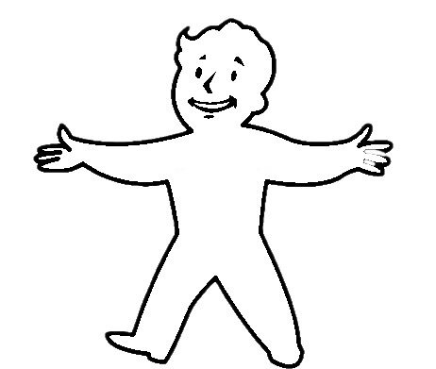

ALIGNMENT | KARMA | XP | RACE | AP | RADS

FACTION RELATIONS | NOTES

